Задание: Подготовить контрольную работу по ранее изученным по темам.
Сроки выполнения: 1 день.
Куда скидывать задание:
на электронную почту alina2007.07@inbox.ru

Тема Занятия: Контрольный срез за II полугодие
Введение
№ 1. Напиши существительные во множественном числе по образцу.
Образец: 3/book – three books

- 2/table- ________________________________________________
- 10/toy-__________________________________________________
- 7/girl-__________________________________________________
- 9/flower-_______________________________________________
- 4/sandwich-_____________________________________________
- 6/T-shirt-________________________________________________
- 8/tree-__________________________________________________
- 5/house-________________________________________________

№ 2. Вставь am / is / are.
- I … happy.
- This … is my brother Tom.
- How old … you? – I … 8 years old.
- Where … mummy and daddy? – they … in the garden.
- The apples … green.
- What … your favourite food? – It … pizza.
- … you in your room? No, I … not.
- It … hot.

№ 3 . Напишите, что было раньше.
Образец: There is an apple in the bag.
There was an apple in the bag.
There are ten cups on the table.
There were ten cups on the table.
- There is a crocodile in the box.
………………………………………in the box.
- There are two sweets in the bag.
…………………………………….in the bag.
- There are four birds in the room.
……………………………………….in the room.
- There is a kitten in the box.
……………………………………..in the box.
5. There are three boxes on the chair.
……………………………………………on the chair.

№ 4 .Составь предложения раскрыв скобки (степени сравнения прилагательных )
1. I am (big) than he.
_________________________________________________________
2. Tom is (small) than his brother.
__________________________________________________________
3. My car is (old) than Tom’s Car.
__________________________________________________________
4.Dolphins are (clever) than fish.
__________________________________________________________
5. Dick is the (tall) in class.
__________________________________________________________
6. Ann is the (high) pupil in class.
________________________________________________________
7. Nick is (clever) in math than Ted.
________________________________________________________

№ 5 . Напишите утвердительные предложения.

Образец: (sing) He is singing
1. ( Wash) He ___________________________________________________
2. (play) They ________________________________________________
3. (Clean) I ___________________________________________________
4. (jump) It __________________________________________________
5. (go) We __________________________________________________

№ 6. Напишите отрицательные предложения.

Образец: (skate) He is not skating
1 (Draw) He______________________________a house.
2. ( ride) They____________________________a bike.
3. ( sing) I_________________________________a song.
4. (jump) It_________________________________
5. ( make) We________________________________bread.
№ 7. Составьте предложения.

Образец; He / skate/ now. He is skating now
1. he/ play tennis/ now.
____________________________________________________________
2. it/ jump/ now/
____________________________________________________________
3. she/ sing/ now.
____________________________________________________________
4.I / help my sister/ now.
____________________________________________________________
5. they / go to school/ now.

№8 Зачеркни лишнее слово:

- Saturday, Monday, Tuesday, October
- orange, potato, tomato, cucumber, carrot
- read, write, happy, play, dance, sing
- crocodile, fox, giraffe, bird, elephant
- ear, neck, face, cake, nose

№9 Реши кроссворд
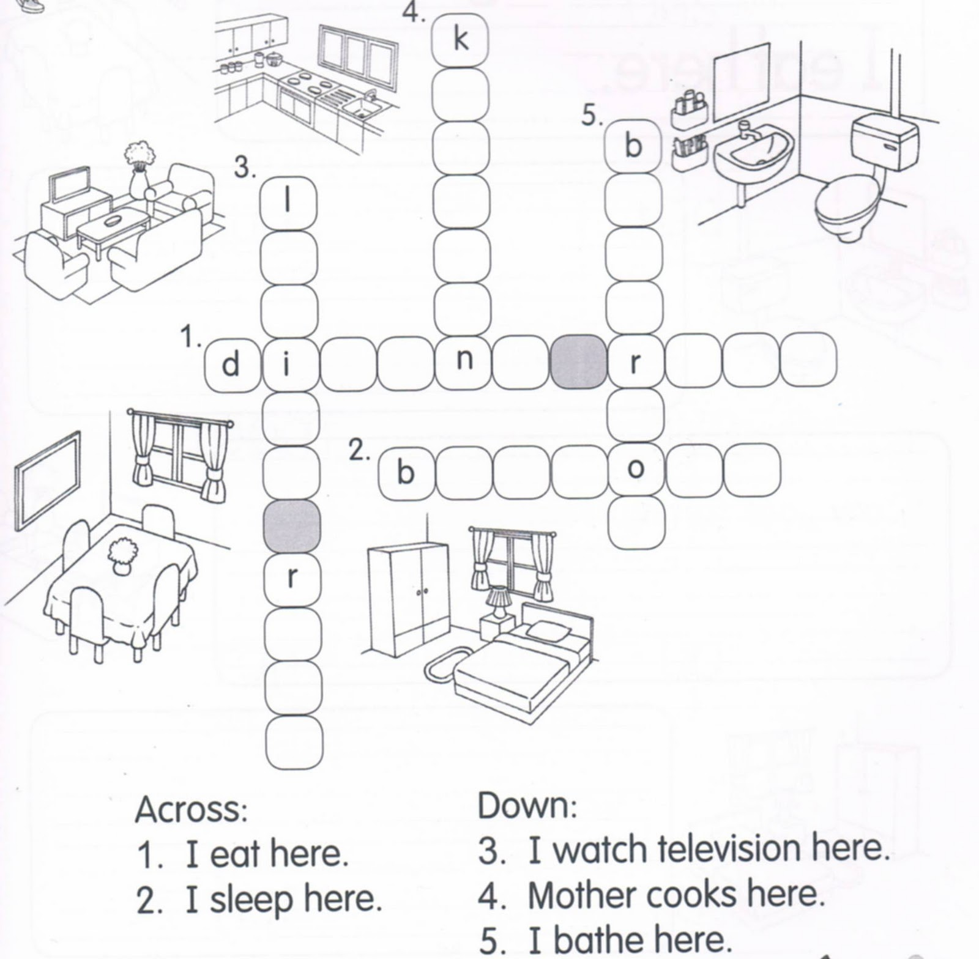

№ 10 Разгадай ребусы ( 2 слова)
